Before using, on the computer you will be using to compile the Python program, install the Python for Windows Extensions (http://sourceforge.net/projects/pywin32/) and py2exe (http://www.py2exe.org/) for the version of Python you are using.

Three files and a fourth phantom file makeup the BH-service project:
setup.py – used for compiling vulnservice
vulnservice.py – the service definition and contents of the bat file
vunservice_task.vbs – the Visual Basic script that will be executed by the service
vulnservice_task.bat – the batch file that will be executed by the service. This file is defined in and created by vulnservice.py

To use vulnservice:

Ensure the three files are in one directory.
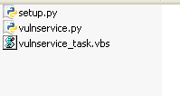

Then use py2exe to create an executable.

By default, py2exe will put the newly created executable into a dist folder. Copy the vulnservice_task.vbs file to the same directory, then install and start the vulnservice. Remember in newer versions of Windows, you may need to “run as” administrator, not just have administrator privileges.

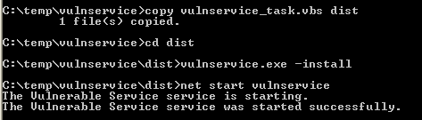

Wait for a minute, then check the logs to see the output

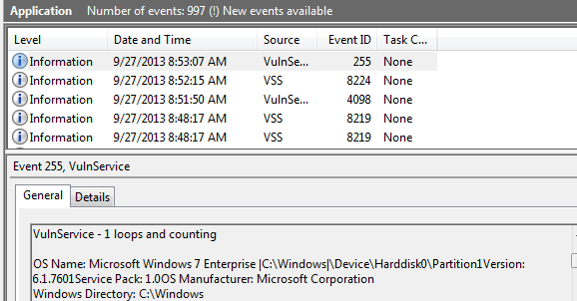

When the required information has been gathered, stop and uninstall vulnservice.

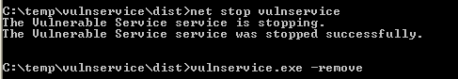

setup.py

from distutils.core import setup
import py2exe

setup(
options = {'py2exe': {'bundle_files': 1}},
service = ['vulnservice'],
zipfile = None,
)

vulnservice.py

#Requires Win32 Python Extensions
import os
import servicemanager
import shutil
import subprocess
import sys
import win32api
import win32event
import win32service
import win32serviceutil

class VulnService(win32serviceutil.ServiceFramework):

_svc_name_ = "VulnService"
_svc_display_name_ = "Vulnerable Service"
_svc_description_ = ("Executes VBScripts and BAT files at regular intervals." +
"What could possibly go wrong?")

def __init__(self, args):
win32serviceutil.ServiceFramework.__init__(self, args)
self.hWaitStop = win32event.CreateEvent(None, 0, 0, None)
self.counter = 0

#Here we put the contents of the batch file to be run.
self.dos_script = """
@echo off
prompt $

echo -------------------------------------------------------------------------------
echo Running Processes:
tasklist

echo -------------------------------------------------------------------------------
netstat -oa

echo -------------------------------------------------------------------------------
echo Available Hosts:
net view

echo -------------------------------------------------------------------------------
echo Admin Users:
net localgroup administrators
exit
"""

def SvcStop(self):
self.ReportServiceStatus(win32service.SERVICE_STOP_PENDING)
win32event.SetEvent(self.hWaitStop)

def SvcDoRun(self):
servicemanager.LogMsg(servicemanager.EVENTLOG_INFORMATION_TYPE,
servicemanager.PYS_SERVICE_STARTED,
(self._svc_name_, 'Service is starting'))

# Fire every minute
self.timeout = 1000 * 60

while True:

# Wait for service stop signal, otherwise loop again
ret_code = win32event.WaitForSingleObject(self.hWaitStop, self.timeout)

# If stop signal encountered, quit
if ret_code == win32event.WAIT_OBJECT_0:
servicemanager.LogInfoMsg("Service is stopping")
break

# Otherwise, run our scripts and log the results to the event log
else:
self.counter += 1
log_output = "VulnService - %d loops and counting\n\n" % self.counter
log_output += self.vbs_task() + "\n\n"
log_output += self.dos_task()
servicemanager.LogInfoMsg(log_output)

def vbs_task(self):
# this function will make a copy of the vulnservice_task.vbs script that is in the same dirctory as the compiled
# Python program, copy it to %temp% of the user or service account the service is running under and execute it.
script_name = "vulnservice_task.vbs"
script_srcpath = "%s\\%s" % (os.path.dirname(sys.argv[0]), script_name)
script_dstpath = "%s\\%s" % (os.environ['TEMP'], script_name)

shutil.copyfile(script_srcpath, script_dstpath)
output = subprocess.check_output("wscript.exe %s" % script_dstpath, shell=False, stderr=subprocess.STDOUT)

os.unlink(script_dstpath)
return output

def dos_task(self):
# This function writes the contentes of the batch script to a file and executes it
script_dstpath = "C:\\TEMP\\vulnservice_task.bat"

with open (script_dstpath, "w") as bat_file:
bat_file.write(self.dos_script)

output = subprocess.check_output("cmd.exe /k %s" % script_dstpath, shell=False, stderr=subprocess.STDOUT)

os.unlink(script_dstpath)
return output

def ctrlHandler(ctrlType):
return True

if __name__ == '__main__':
win32api.SetConsoleCtrlHandler(ctrlHandler, True)
win32serviceutil.HandleCommandLine(VulnService)

vulnservice_task.vbs
' Adapted from:
' http://gallery.technet.microsoft.com/scriptcenter/03f21031-07de-4a26-9a04-4871cd425870

strComputer = "."
Set objWMIService = GetObject("winmgmts:" _
& "{impersonationLevel=impersonate}!\\" & strComputer & "\root\cimv2")

Set colSettings = objWMIService.ExecQuery _
("Select * from Win32_OperatingSystem")

For Each objOperatingSystem in colSettings
Wscript.StdOut.Write "OS Name: " & objOperatingSystem.Name & vbCrLf
Wscript.StdOut.Write "Version: " & objOperatingSystem.Version & vbCrLf
Wscript.StdOut.Write "Service Pack: " & _
objOperatingSystem.ServicePackMajorVersion _
& "." & objOperatingSystem.ServicePackMinorVersion & vbCrLf
Wscript.StdOut.Write "OS Manufacturer: " & objOperatingSystem.Manufacturer & vbCrLf
Wscript.StdOut.Write "Windows Directory: " & _
objOperatingSystem.WindowsDirectory & vbCrLf
Wscript.StdOut.Write "Locale: " & objOperatingSystem.Locale & vbCrLf
Wscript.StdOut.Write "Available Physical Memory: " & _
objOperatingSystem.FreePhysicalMemory & vbCrLf
Wscript.StdOut.Write "Total Virtual Memory: " & _
objOperatingSystem.TotalVirtualMemorySize & vbCrLf
Wscript.StdOut.Write "Available Virtual Memory: " & _
objOperatingSystem.FreeVirtualMemory & vbCrLf
Wscript.StdOut.Write "Size stored in paging files: " & _
objOperatingSystem.SizeStoredInPagingFiles & vbCrLf
Next

Set colSettings = objWMIService.ExecQuery _
("Select * from Win32_ComputerSystem")

For Each objComputer in colSettings
Wscript.StdOut.Write "System Name: " & objComputer.Name & vbCrLf
Wscript.StdOut.Write "System Manufacturer: " & objComputer.Manufacturer & vbCrLf
Wscript.StdOut.Write "System Model: " & objComputer.Model & vbCrLf
Wscript.StdOut.Write "Time Zone: " & objComputer.CurrentTimeZone & vbCrLf
Wscript.StdOut.Write "Total Physical Memory: " & _
objComputer.TotalPhysicalMemory & vbCrLf
Next

Set colSettings = objWMIService.ExecQuery _
("Select * from Win32_Processor")

For Each objProcessor in colSettings
Wscript.StdOut.Write "System Type: " & objProcessor.Architecture & vbCrLf
Wscript.StdOut.Write "Processor: " & objProcessor.Description & vbCrLf
Next

Set colSettings = objWMIService.ExecQuery _
("Select * from Win32_BIOS")

For Each objBIOS in colSettings
Wscript.StdOut.Write "BIOS Version: " & objBIOS.Version & vbCrLf
Next

